## What’s the point?

The derivative seeks to answer one of the classic calculus problems: the tangent line problem, where given a function and one point on it, you must find the line tangent to the curve. In general terms, the derivative is the slope of the tangent line.

What does this look like? Here, $g(x)$ is the tangent line to the graph of $f(x)$ when $x=3$. Both $f\left(x\right) and g(x)$ share the same slope at $x=3$ and only meet at one point



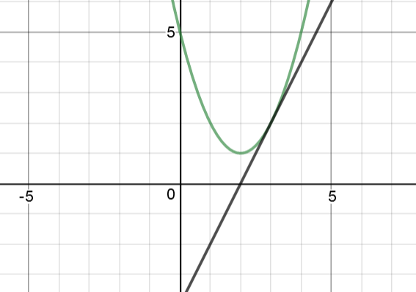

## General limit definition

$$f^{'}\left(x\right)=\lim_{∆x→0}{\frac{f\left(x+∆x \right)-f(x)}{∆x}}$$

To better understand this definition, look at how It was developed.

$$m= \frac{∆x}{∆y}= \frac{y_{2}-y_{1}}{x_{2}-x_{1}}= \frac{{f(x}_{2})-{f(x}_{1})}{x_{2}-x_{1}}= \frac{f(x_{1}+ ∆x)-f(x_{1})}{∆x+x_{1}- x_{1}}=\frac{f(x+ ∆x)-f(x)}{∆x}$$

This finds average slope over an interval and can be used to approximate the slope of a function at a point (This approximation is a secant line). By decreasing $∆x$ the approximation becomes more accurate, so using the limiting process we can find the exact value of the slope at a point.

**EXAMPLE 2:**

Jonathan can solve a Rubik’s Cube in 10 seconds. This year he started keeping track of his improvement. His average solving time in seconds after x months is modeled by the function $f\left(x\right)=\frac{10}{x+1}$. Jonathan wants to know how fast he is improving at month 4. Find the equation of the tangent line to the graph at the given points.

Solution:

Important information: $f\left(x\right)=\frac{10}{x+1}$, find the equation of the tangent line when $x=4$

First, find the slope of the function (and the tangent line) where $x=4$

This is accomplished using the limit definition of the derivative

$$m=\lim_{∆x→0}{\frac{f\left(x+∆x \right)-f(x)}{∆x}}→\lim_{∆x→0}{\frac{\left(\frac{10}{∆x+5}\right)-\left(\frac{10}{5}\right)}{∆x}}$$

$$→\lim_{∆x→0}{\frac{\frac{50-10∆x-50}{\left(∆x+5\right)\left(5\right)}}{∆x}}→\lim_{∆x→0}\left(\frac{-10∆x}{\left(∆x+5\right)\left(5\right)}\left(\frac{1}{∆x}\right)\right){}$$

$$\underset{∆x→0}{→lim}\left(\frac{-10}{\left(5∆x+25\right)}\right)→-\frac{10}{0+25}→\frac{-2}{5}$$

Now that we have found the slope of the tangent line is $-\frac{2}{5}$, we must find the full equation for the tangent line using this formula: $y-y_{1}=m(x-x_{1})$

Find $y_{1}$ from the original function and x coordinate

$$y_{1}=\frac{10}{4+1}=2$$

Now plug these into the formula to get the equation for the tangent line at $x=4$

$$y-2=\frac{-2}{5}(x-4)$$

## When is a function not differentiable?

There are 3 reasons a function might not be differentiable: The function is not continuous, has a sharp turn or cusp, or has a vertical tangent line.

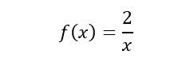

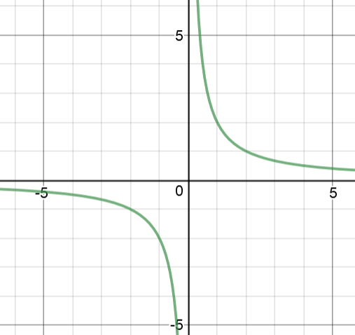

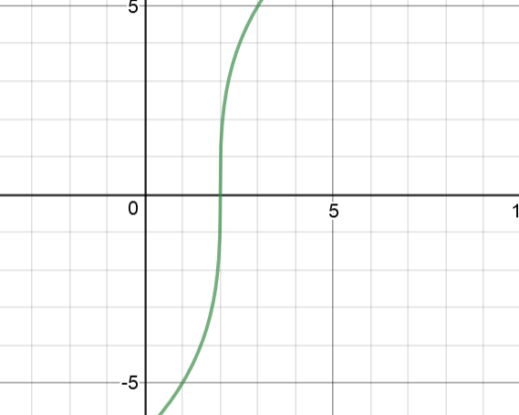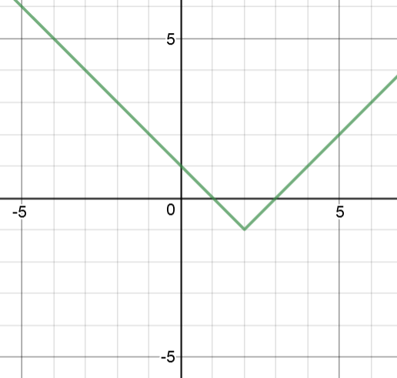

is not differentiable because it has a vertical tangent line at $x=2$ where its slope is undefined

$f$ is not differentiable because it is discontinuous at $x=0$.

$g$ is not differentiable because it has a sharp turn at $x=2$ where the slope suddenly changes

**Important note:**

If a function is differentiable it is also continuous, but not all continuous functions are differentiable. Differentiability implies continuity but continuity does not imply differentiability.